Jackson McAtee

MPCS 57200, Generative AI

Homework 4

Homework 4-1
I wanted to make a model that predicts economic recessions in the US, and create an application that shows predictions, feature importances, and historical data in an easily navigable dashboard.
I approached this task using three methods: old school hand-coding, using a chat window to work with claude and copy/paste code responses into visual studio code, and full on agentic “vibe-coding” using claude code. My biggest takeaway is that the old school way of coding is already obsolete. The amount of time it took to create a very basic logistic regression model and spin up a simple UI, compared to typing into an LLM chat window was astounding. Additionally, the features and quality of the dashboard were much higher leveraging LLMs.
One thing I did notice, is that claude does tend to over-engineer. This may be helpful, but for simple tasks this can make the code base much more complicated than necessary. It can make human review and understanding much more tedious.
Let’s take a look at two examples: claude in the chat window, versus claude code.

Claude in Chat Window (Copy paste into VS Code):
This method was a huge improvement from the hand code technique. It clearly outlines widgets and calculates metrics in a neat and presentable way. Additionally, there were some liberties taken such as adding a brier score, which I did not explicitly ask for.
This is a good proof of concept, but I do not believe it is a production ready dashboard or application.
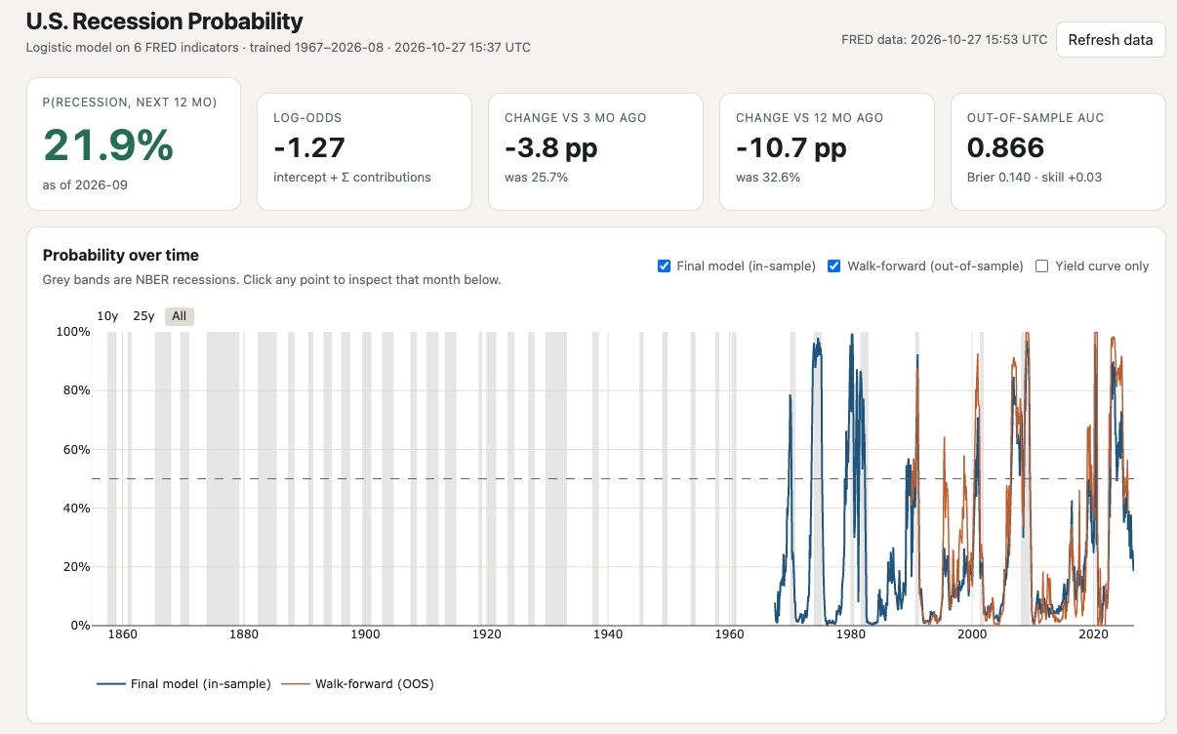
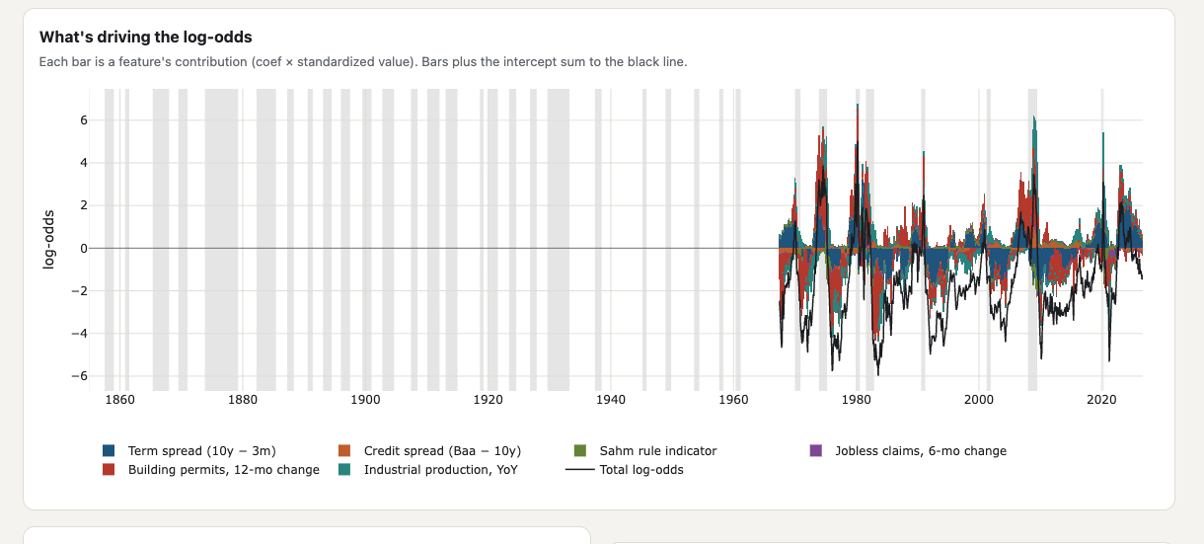
Claude Code:
Prompt: “create an app using fastapi that predicts recessions in the next twelve months using logistic regression, random forest, and xgboost. Compare the three and an ensemble method. Choose the best model and push it to production.
The production app should show the model, the feature importances, the predictions in the future, time series results, and anything else that you think would be important. Make this a clean and sophisticated app that a finance professional would use. I do have a fred api key, so create an example env doc and I will put it in their afterwards.”
This is an incredibly simple prompt for the amount of work and output of the codebase. There are over 17 files created, including code to maintain a virtual environment, docker image, and git repository. None of these were specifically asked for but are best engineering principles and were included by the AI.
The dashboard is clean and creates helpful widgets, easily digestible. I really like how it stacks up the different models against one another and shows their strengths and weaknesses. Additionally, the app is explicit about which model it is using and how it was built. A really important feature is the metadata associated with the trained production model, including timestamps, reason it was chose, number of features, and explicit hyperparameters. This is crucial to responsible and explainable AI. I did not ask for this feature, but claude code added this. This is a large difference between the chat window and claude code approach. Claude code tends to make more assumptions and design decisions for you.
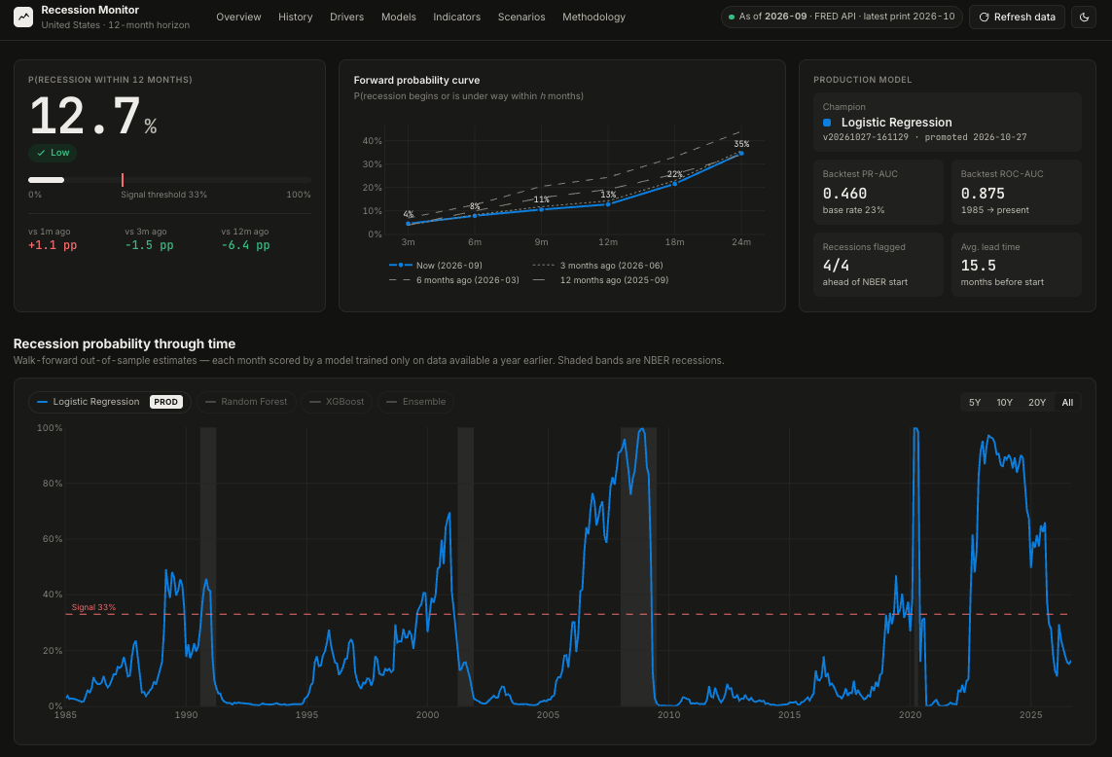

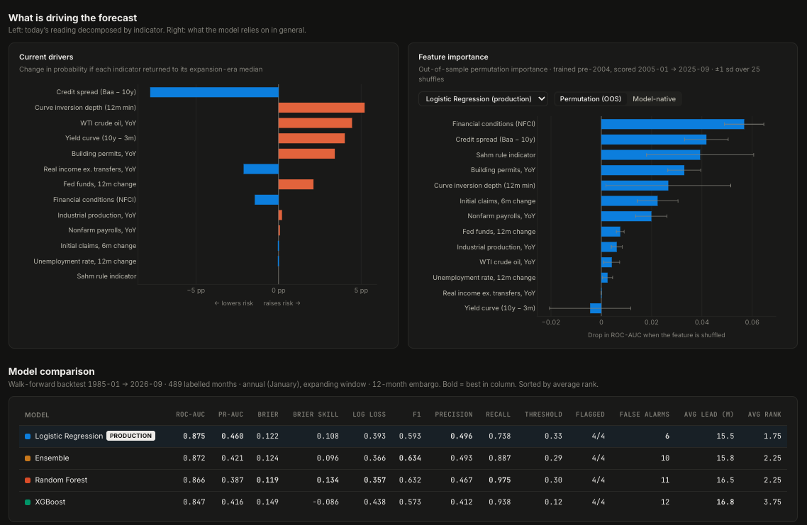
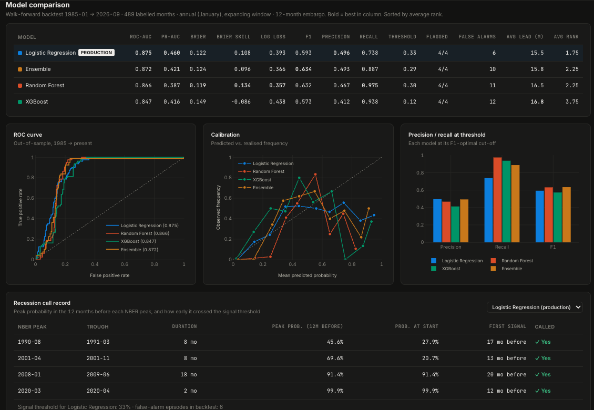
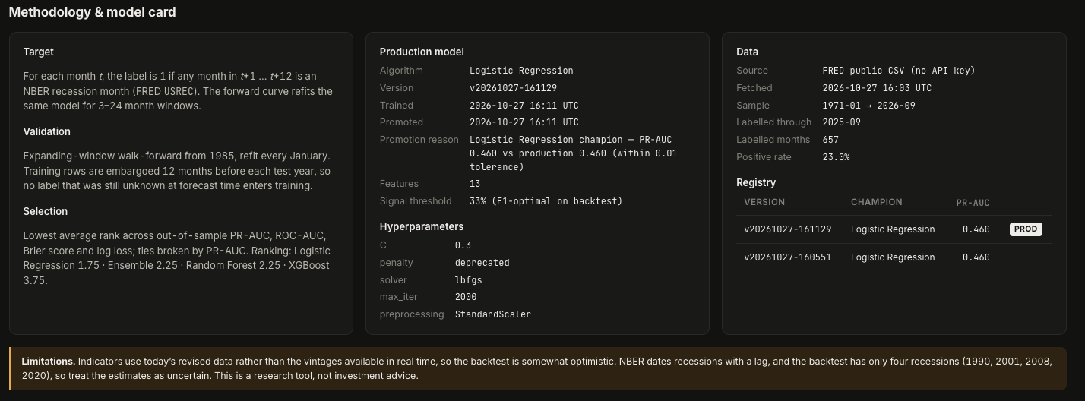

Homework 4-2
Responsible AI is an idea that we must all strive for. In the classroom, workplace, and our personal lives. This phrase is thrown around in executive committees and board rooms, but I feel there is a lot of confusion around the term. IBM defines responsible AI as “a set of principles that help guide the design, development, deployment and use of AI—building trust in AI solutions that have the potential to empower organizations and their stakeholders”. I do think this is a good north star, but is an incredibly broad and wide-ranging statement, and must be tailored towards each entity specifically.
One pillar of responsible AI, in my view, is the human in the loop. This is constantly praised and put in front of us with ideas like Human in the loop design (HITL), but is it really followed? In 2025, github recorded 1 billion commits. In 2026, this number is expected to be 14 billion. There is a clear increase in pace caused by artificial intelligence and agentic coding. The question we must ask is: how much of this code is genuinely being reviewed?
In my experience, agentic coding feels so good that its prompters rarely even feel they need to read the output. Or if they do read the code, they passively look at it and say “oh that makes sense”. We say there is human oversight, but I think humans are inclined to take the path of least resistance, and we are falling out of touch with our codebases. I witnessed this at my internship this summer and looking at a friend’s technology startup, run by two non-engineers.
It is possible that agentic coding tools and their guardrails are so sophisticated that we can be completely hands off. However, I do not believe this is the case, and think this view is the antithesis of responsible AI.
My prediction is that vibe coded apps, fast pace of production, and products and startups led by people with non-technical fluency will create massive technical debt. We have seen sophistication in cybersecurity tools using AI’s frontier models in incidents like the Hugging Face attack and PHP vulnerabilities. I believe that there will be a larger surface area for attack with less oversight, less technical knowledge, and faster pace; which hackers and/or AI will continue to exploit. The past attacks have galvanized calls for slowdown, but very little has actually come to fruition. I believe that it will take a massive, painful attack on critical infrastructure or a financial institution for people to take these threats seriously. It will be too late at that point, and I believe that we are headed in this direction. Everyone is so enamored by productivity gains, technology pace and competition, that they are indirectly losing sight of their responsibility to have a human truly in the loop.

https://medium.com/@naro7217/how-github-handles-billions-of-commits-while-ai-coding-tools-flood-the-platform-aa02577be670

